AI-Enhanced Career Guidance System

Zarinabegam Mundargi
AIDS Department
Vishwakarma Institute of Technology, Pune, India
zarinabegam.mundargi@vit.edu

Mohan Kabade
AIDS Department
Vishwakarma Institute of Technology, Pune, India
mohan.kabade22@vit.edu

Aditi Harale
AIDS Department
Vishwakarma Institute of Technology, Pune, India
aditi.harale221@vit.edu

Parth Kale
AIDS Department
Vishwakarma Institute of Technology, Pune, India
parth.kale22@vit.edu
Jainivas Anandhan
AIDS Department
Vishwakarma Institute of Technology, Pune, India
jainivas.anandhan22@vit.edu

Pradunya Kale
AIDS Department
Vishwakarma Institute of Technology, Pune, India
pradunya.kale22@vit.edu

Abstract– In a world increasingly shaped by technological transformation, the career paths of students and professionals alike have become dynamic and complex. Traditional counseling methods often fall short in addressing individual aspirations, evolving industry demands, and fast-changing skill landscapes. To bridge this gap, our research proposes an intelligent AI-driven Career and Skill Recommendation System. This system acts as a personalized mentor, utilizing machine learning and natural language processing (NLP) to analyze user inputs such as academic scores, resume content, and self-declared skills. By identifying potential career trajectories and skill deficiencies, it suggests tailored upskilling resources from platforms like Coursera, Udemy, and LinkedIn Learning. Furthermore, the integration of a user-friendly graphical interface and a generative AI chatbot ensures an engaging, responsive, and accessible experience. This project not only empowers users with actionable career insights but also represents a scalable model for future career guidance platforms.

Keywords: Artificial Intelligence, Career Guidance, Machine Learning, NLP, Recommendation system, RAG chatbot

I. INTRODUCTION
In today’s digital age, career development has evolved into a deeply personalized and dynamic endeavor, moving far beyond the traditional paradigms of static job suggestions and generic counseling. As the global workforce becomes increasingly digital and interconnected, individuals are confronted with an overwhelming abundance of career options, skill requirements, and educational paths. The journey to choose and build a successful career has become more complex, and this complexity necessitates the involvement of intelligent systems capable of delivering tailored guidance based on personal strengths, interests, and evolving market demands.
The limitations of conventional career counseling models are evident. Historically, students and professionals have relied heavily on academic advisors, counselors, or rudimentary aptitude tests to determine their career directions. These methods often operate within constrained frameworks, lack scalability, and provide one-size-fits-all recommendations. In contrast, the modern digital environment demands agility, adaptability, and a continuous learning mindset. This paradigm shift has prompted researchers and technologists to explore new methodologies for career planning and upskilling, driven by Artificial Intelligence (AI) and Machine Learning (ML).
At the forefront of this movement is the concept of AI-driven career recommendation systems, designed to understand individual user profiles deeply and map them to optimal career paths. These systems combine the power of data analytics, natural language processing (NLP), supervised learning, and recommendation engines to derive insights that were previously unattainable through manual processes. By aggregating diverse data points — academic scores, work experience, skill inventories, learning patterns, and job market trends — AI can form a holistic view of an individual and deliver recommendations that align with personal goals and external opportunities.
This research presents the development of a Career and Skill Recommendation System empowered by AI and ML, with a user-friendly interface tailored to both students and working professionals. The objective is to bridge the gap between personal aspirations and professional expectations by delivering personalized career advice, identifying skill gaps, recommending learning paths, and enabling continuous professional development. The system is built around a dual-mode interface: one for students exploring their future options and another for professionals seeking career advancement or transition.
The student module of the system is grounded in educational data mining. It takes into account academic performance across various subjects, participation in extracurricular activities, attendance patterns, and self-study habits. These inputs are processed using trained ML models that classify and rank career options based on patterns learned from historical data. For example, a student demonstrating strong aptitude in mathematics and physics, alongside active participation in technical clubs, might be recommended careers in engineering or data science. The recommendations are not just suggestions but actionable insights backed by data, enabling students to plan their academic journey with clarity.
On the other hand, the professional module is designed for individuals already in the workforce. Professionals often find it challenging to identify opportunities for growth, particularly when trying to pivot to new roles or industries. Here, our system leverages NLP to extract relevant skills, experiences, certifications, and achievements from resumes or LinkedIn profiles. These attributes are then matched against job role requirements sourced from employment platforms and industry databases. The output includes both potential job roles and the additional skills or certifications needed to qualify for them. This AI Resume & Experience Mapping becomes an invaluable tool for professionals navigating an ever-changing job market.
Skill Gap Analysis is a cornerstone of the system. Identifying missing competencies and recommending resources to address them is crucial for meaningful career progression. Our platform uses NLP and content-based filtering techniques to analyze job descriptions, resumes, and user profiles to detect gaps between current capabilities and desired roles. It then suggests tailored learning paths using curated courses from popular platforms like Coursera, Udemy, and LinkedIn Learning. This enables users to address deficiencies proactively and align themselves with industry standards.
A key innovation in our system is the integration of a Retrieval-Augmented Generation (RAG)-based chatbot. This generative AI model is trained on domain-specific knowledge and is capable of engaging users in meaningful conversations. It can answer career-related questions, suggest certifications, explain the relevance of different fields, and even offer motivational advice. By embedding this chatbot into the UI, the system transforms from a static tool into a dynamic mentor, available around the clock.

II. LITERATURE REVIEW
The research paper authored by Harshal Gupta, titled “AI Powered Career Advisor: Bridging the Gap between the Aspirations and Opportunities”, published on April 2025. The paper explores how AI can enhance career guidance by offering personalized, data-driven recommendation. Using machine learning, NLP and real-time job market analysis, the proposed system aligns user skills and interests with suitable career paths. It highlights the benefits of AI in improving employability and decision-making while addressing challenges like data bias and personalization[1].

The research paper authored by Yash Jain, titled “AI-Based Personality Prediction and Career Recommendation from Social Media Posts”, published on April 2025. This paper presents an AI-based system that uses NLP and machine learning to analyse social media posts for predicting personality traits(using the Big Five model) and recommending suitable careers. It collects and processes data from platforms like Twitter and Reddit, applies a fine tuned RoBERT model for trait analysis, and maps results to careers through a compatibility matrix. The system is accessible via a web interface and offers a scalable, automated alternative to traditional career counselling[2].

The research paper authored by Stina Westman, titled “Artificial Intelligence for Career Guidance – Current Requirements and Prospects for the Future”, published in 2021. This paper explores integrating Artificial Intelligence(AI) into career guidance in higher education to support lifelong learning amid a rapidly evolving labour market and growing demands for upskilling. Through focus groups, scenario analysis, and trials, it identified how AI can enhance accessibility, efficiency and personalization of guidance, benefiting students, professionals and institutions. It highlights the importance of personal, proxy, and collective agency in guidance and discusses technological, organizational and ethical challenges in adopting AI. The authors recommending further research on developing guidance data ecosystems and ethical frameworks for ethical AI use[3].

The research paper authored by Menaka Gandhi, titled “Integrating Deep Learning and Bayesian Network for Personalized Career Guidance”, published on April 2025. This paper presents an AI-Powered career guidance system that integrates Deep Learning and Bayesian networks to offer personalized, data-driven career recommendations based on individual profiles and real-time job market trends. By incorporating Explainable AI methods, it ensures transparent and trustworthy advice, helping users understand the reasoning behind suggestions. The system continuously adapts to industry changes and provides an interactive platform with detailed career insights, enabling users to make informed decisions that enhance career satisfaction and reduce mismatches[4].

The research paper autyhored by Ai-chu Elisha Ding, titled “Enhancing teacher AI literacy and integration through different types of cases in teacher professional development”, published on 9 April 2024. The study found that a case-based professional development program improved middle school science teachers AI literacy. Using cases of varying complexity, the program enhanced teachers understanding of AI and their problem solving skills. Teachers showed the most growth in understanding in AI concepts, especially when discussing complex, real world cases. The study suggests that combining direct instruction with diverse case discussions is effective for teaching AI integration in education, helping educators confidently apply AI knowledge in classroom settings[5].

The research paper authored by Yanzhen Lan, titled Through tensions to identify-based motivations: Exploring teacher professional identity in Artificial Intelligence-enhanced teacher training”, published on 22 August 2024. The study examines how AI-enhanced teacher training impacts professional identity in a Chinese University. Using Identity based motivation and self-determination theory. It identifies tensions between individuality and groupness, humanity and technology, and continuity and changes. Based on surveys and interviews the study introduces AI roles – Navigator, Collaborator , and Inventor – emphasizing that effective AI integration must align with teachers identities and motivations, supporting personalized growth and ethical, reflective practice[6].

The research paper authored by Pratiyush Guleria, titled “Explainable AI and machine learning: performance evaluation and explainability of classifiers on educational data mining inspired career counselling”, published on 16 July, 2022. This paper proposes a machine learning and explainable AI framework to improve career counselling by analysing students academic and employability data. It uses interpretable white box models and accurate but complex black box models, with XAI techniques to explain decisions and build trust. The system helps students choose suitable careers based on diverse data inputs, outperforming traditional counselling. Naïve Bayes achieved the best prediction results, demonstrating the framework’s effectiveness in providing personalized, data-driven career guidance[7].

The paper authored Adan Jose – Garcia, titled “C3-IoC: A Career Guidance system for Assessing Student Skills using Machine Learning and Network Visualization published on 1 December 2022. The paper presents C3-IoC, an AI-driven career guidance system that helps students explore and plan careers in the evolving IT sector by assessing both technical and non-technical skills. CE-IoC integrates machine learning and text mining to analyse up-to-date job market data, creating a dynamic knowledge base from job ads and taxonomies. It profiles users skills through CV parsing and self assessment, then matches and visualizes these against a network of relevant IT job roles. This helps students understand the skills needed for emerging jobs, raises awareness of soft skills, and supports smoother transitions from education to employment[8].

III. METHODOLOGY
The architecture of our AI-powered Career and Skill Recommendation System is designed to provide a holistic, personalized experience for users, guided by a modular yet interconnected approach. The system is composed of three major components: the Student Career Recommendation Model, the Career Gap Identification and Upskilling Model for professionals, and a Conversational Chatbot based on Retrieval-Augmented Generation (RAG). These modules are orchestrated within an interactive user interface built using Gradio, which dynamically adapts based on whether the user is a student or a working professional. Data processing, model inference, and user interaction are all managed through backend pipelines that utilize NLP, supervised learning, and recommendation algorithms, enabling real-time feedback and accurate predictions.

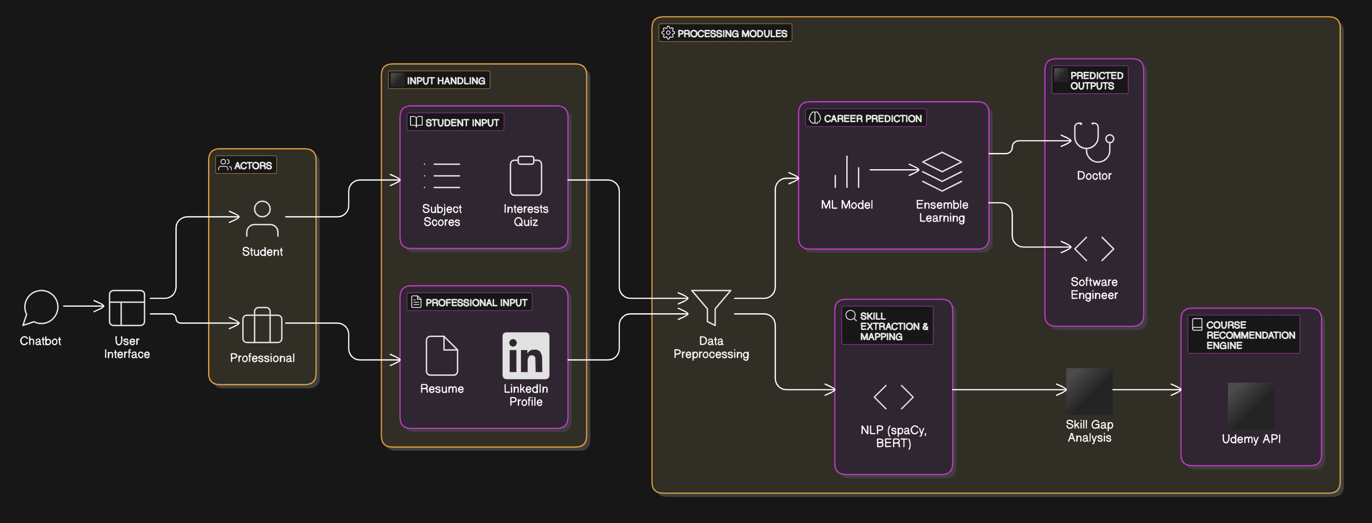
Fig. 1: System Architecture

- Student career recommendation
This component predicts a student's ideal career path based on their academic performance and selected personal attributes. The dataset used consisted of individual student information, including subject-wise marks and demographic features. Irrelevant identifiers such as ID, first name, last name, and email addresses were removed to maintain privacy. To better represent academic performance, additional features like total score and average score were engineered. Categorical variables—including gender, part-time job status, extracurricular participation, and career aspirations—were converted into numerical format using label encoding to ensure compatibility with machine learning algorithms. To address class imbalance in the career aspiration labels, the Synthetic Minority Over-sampling Technique (SMOTE) was applied. This oversampling method generated synthetic instances of minority classes to create a more balanced training dataset. The preprocessed dataset was divided into training and testing subsets in an 80:20 ratio. Feature scaling was performed using standard normalization (StandardScaler) to ensure uniformity across all numerical input variables. A diverse set of classification algorithms was implemented, including Logistic Regression, Decision Tree, Random Forest, Support Vector Machine (SVM), K-Nearest Neighbors (KNN), Naive Bayes, and Boosting methods like LightGBM and Gradient Boosting.

Each model was trained on the preprocessed training data and evaluated using accuracy and confusion matrix metrics to determine the most effective approach for the prediction task. Ultimately, the Random Forest algorithm was chosen as the final classification model. After training on the preprocessed dataset, the model was evaluated using accuracy and confusion matrix metrics. Random Forest was selected for its robustness, ability to handle high-dimensional data, and effectiveness in capturing complex feature interactions relevant to career prediction.
.
- Skill Gap Analysis:
The Career Gap Identification and Upskilling Model is a core component designed to assist professionals in understanding how their current skill set aligns with desired industry roles. Unlike static job boards or manual assessments, our model employs a data-driven and algorithmic approach to evaluate user profiles, identify gaps, and suggest actionable upskilling paths. This ensures that professionals are not just informed of where they fall short but are also guided on how to bridge those gaps using targeted learning resources.

The process begins with resume ingestion, where the user either uploads a resume document (PDF or DOCX) or manually enters skills, certifications, and experience details. Using Natural Language Processing (NLP) techniques such as Named Entity Recognition (NER), part-of-speech tagging, and dependency parsing, the model extracts relevant entities like tools (e.g., Python, Excel), frameworks (e.g., TensorFlow, Spring Boot), certifications, and job roles from the unstructured text. Libraries such as SpaCy and Hugging Face Transformers are employed for semantic extraction and sentence vectorization.

Next, the system performs job-role profiling by comparing the extracted skill set against a curated database of industry-standard job descriptions. These job descriptions are encoded using TF-IDF (Term Frequency-Inverse Document Frequency) vectors or sentence embeddings such as BERT or Sentence-BERT.
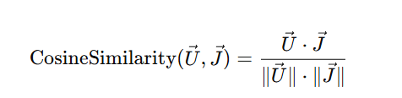
Equation 1: Cosine Similarity
Where:
- U⃗ is the user's current skill vector
- J⃗ is the target job role vector

This similarity score indicates the degree of alignment between the user and the target job. Lower scores suggest a larger career gap, triggering the next phase of analysis.

To make the upskilling journey actionable, the model recommends courses from platforms like Coursera, Udemy, and LinkedIn Learning. While basic keyword or metadata matching helps identify relevant courses, we integrate Singular Value Decomposition (SVD)—a matrix factorization technique from collaborative filtering—to improve personalization.

A user-item matrix is created, where rows represent users and columns represent courses. The entries are either explicit (user ratings) or implicit (clicks, enrollments). SVD decomposes this matrix A into three matrices:

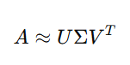
Equation 3: SVD Factorization

where:
- U is the user latent feature matrix,
- Σ is the diagonal matrix of singular values,
- V is the item (course) latent feature matrix.

Courses with the highest predicted scores that also match the skill gap are prioritized and recommended to the user. This hybrid approach—combining content-based filtering (matching missing skills to course metadata) and collaborative filtering via SVD—ensures recommendations are both relevant and personalized.

- RAG Chatbot:

In continuation of the previous modules, the third component of the system integrates a retrieval-augmented conversational agent that enables dynamic career guidance through intelligent interaction. This chatbot employs a hybrid architecture combining local large language modeling with semantic retrieval to generate personalized, context-aware responses. The underlying large language model (LLM) used in this work is Llama 3.2, executed locally via the Ollama framework hosted on http://localhost:11434/v1. The model operates at a temperature parameter of 0.7, striking an optimal balance between creative language generation and deterministic consistency.

The input data for this module comprises two major datasets — one containing specializations and their associated skills, and another describing IT job roles, job descriptions, and skill requirements. The specialization dataset is formatted such that each record forms a textual unit:
s_{i} = "Specialization" + Spec_{i} + "Skills Required: " + Skills_{i}.
Each such string is encapsulated as a LangChain Document object with metadata storing the specialization and skill fields. Similarly, the IT job dataset (sourced from data/encoded-IT_Job_Roles_Skills.csv) is preprocessed by removing non-essential columns such as Certifications and restructuring each entry as
𝑗_{𝑖}="Job Title: "+𝑇_{𝑖}+"Job Description: "+𝐷_{𝑖} +"Skills: "+S_{i}
Each entry is again represented as a Document containing both raw text and metadata for efficient retrieval. The combined corpus 𝐷 thus consists of both specialization- and job-based documents, enabling the system to answer queries relating to either domain.

To facilitate efficient information retrieval, the textual corpus is vectorized using HuggingFace’s Sentence Transformer model all-MiniLM-L6-v2, which generates dense 384-dimensional semantic embeddings. Each document x_{i} ∈ D is transformed into a continuous vector representation v_{i} = f_{𝜃}(x_{i}) ∈ R³⁸⁴, where
𝑓_{𝜃} denotes the transformer’s encoding function. These embeddings are stored in a Chroma vector database, specified with persist_directory="merged_db", ensuring persistence across sessions. For every user query, the retriever module selects the top k=5 most semantically relevant documents to construct the contextual foundation for response generation.

On top of this retrieval layer, a Conversational Retrieval Chain (CRC) from LangChain is employed to orchestrate the dialogue. The chain integrates the ChatOllama model as the language generator, the Chroma retriever as the knowledge source, and a ConversationBufferMemory module to maintain session-level coherence. Formally, at dialogue step t, the system produces the response

A_{t} = LLM(Prompt(q_{t}, R_{k}, H_{t}))

where 𝑞_{𝑡} is the current user query, 𝑅_{𝑘} is the set of top-k retrieved documents, and $${H_{t}=\{(u_{i},b_{i})\}}_{i=1}^{t-1}$$
denotes the conversation history consisting of prior user–bot exchanges. This mechanism ensures that each generated answer is both contextually grounded in the retrieved knowledge and consistent with the ongoing dialogue.

Prompt engineering plays a crucial role in tailoring the model’s behavior. A structured prompt template instructs the chatbot to act as a friendly career mentor, leveraging only the retrieved context to produce informative and motivational responses. The prompt dynamically incorporates the user query, relevant document excerpts, and previous messages to form a context-enriched input. This design eliminates hallucination by confining the model’s reasoning to retrieved knowledge, while still allowing creativity through the Llama 3.2’s generative capabilities.

Overall, this methodology enables the chatbot to serve as a robust career-assistant framework that retrieves semantically relevant occupational data and translates it into engaging, human-like responses. The combination of vector-based retrieval, transformer embeddings, and locally executed LLM inference ensures both interpretability and privacy, distinguishing it from traditional cloud-based conversational systems.

IV. RESULTS-SYSTEM DEMONSTRATION
The AI-powered Career and Skill Recommendation System has demonstrated meaningful outcomes for students, especially those at the early stages of their academic journey. By leveraging inputs such as academic scores, extracurricular participation, learning behavior, and more, the system accurately identifies potential career paths aligned with students’ strengths and interests. This has resulted in greater clarity among students when selecting educational streams or considering higher studies, thus reducing uncertainty and reliance on generic advice.

For professionals, the system has proven to be a dynamic career assessment and planning tool. By parsing resumes and extracting skills, tools, certifications, and experience using NLP pipelines, the system compares the user’s profile with industry job descriptions. The resulting recommendations provide targeted upskilling resources, lateral job movement suggestions, or promotional readiness analysis. This has helped professionals understand their position in the job market, uncover areas for improvement, and act strategically toward career advancement or role transition. The career mapping capability has also facilitated better decision-making in dynamic job environments, including IT, data science, and management sectors.

The inclusion of a generative AI chatbot based on Retrieval-Augmented Generation (RAG) has substantially enhanced user engagement and support. Acting as a 24/7 on-demand career coach, the chatbot answers user queries regarding course details, job expectations, interview preparation, or skill enhancement pathways. It maintains a conversational and supportive tone, increasing trust and interactivity. Students often use the chatbot to validate doubts about career paths, while professionals rely on it for advice on certifications or platform comparisons. Its integration has transformed the platform from a static recommender into an ongoing, interactive career companion that evolves with the user’s goals and feedback.

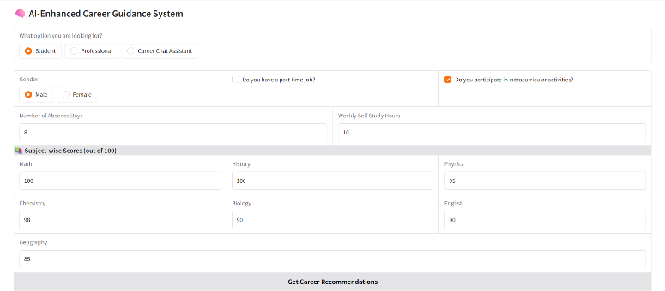

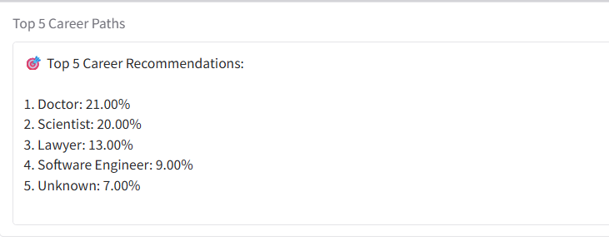
Fig 2. Career Recommendation System for Students

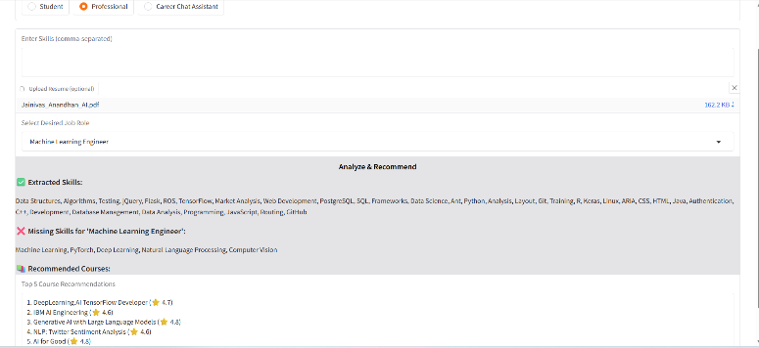
Fig 3. Skill Gap Analysis System for Professionals

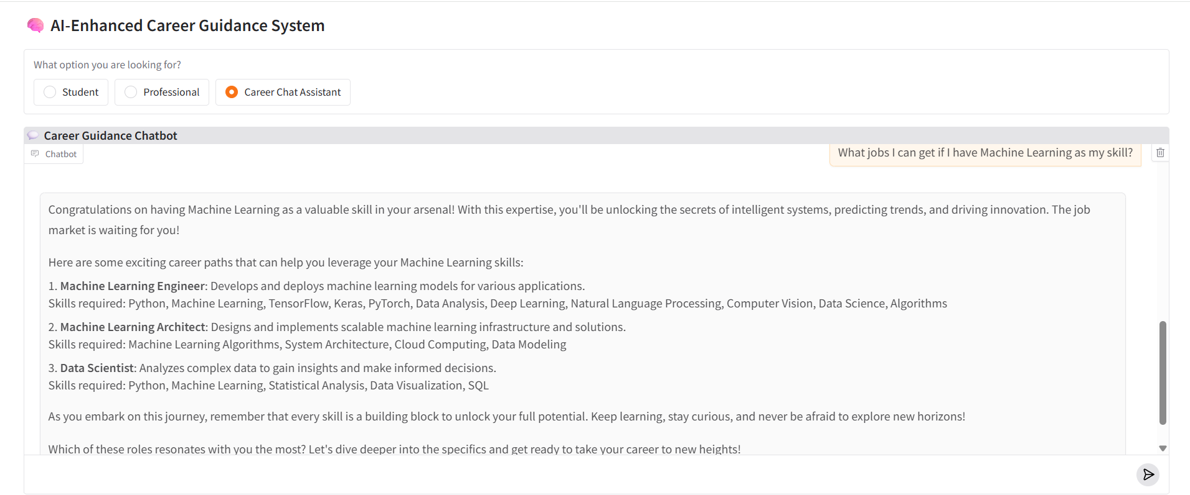
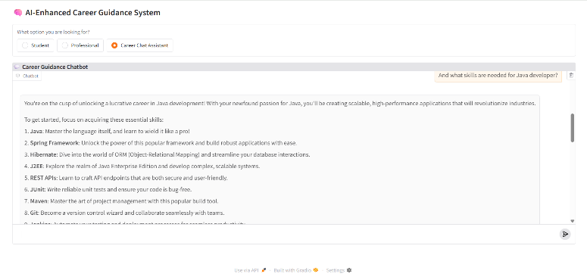
Fig 4. Career Guidance Chatbot
V. CONCLUSION
In conclusion, the AI-based Career and Skill Recommendation System introduced in this project addresses one of the most pressing needs in modern career planning—personalized, data-driven, and adaptive guidance. By combining machine learning models, natural language processing, and recommendation algorithms, it serves both students and professionals with contextual career insights. The interface, built using Gradio, ensures inclusivity, while the RAG-powered chatbot provides conversational career coaching. Together, these components form a comprehensive system that empowers users to make informed academic and professional decisions, while continuously enhancing their skill sets.
Looking forward, the project is both vast and impactful. Integration with real-time job portals, LinkedIn profiles, or academic institutions’ Learning Management Systems (LMS) can enrich the recommendation engine. Expanding the dataset to include global job trends, soft skill analysis, and peer-reviewed learning paths can improve recommendation accuracy. Additionally, multilingual chatbot support and mobile app deployment can extend the system’s accessibility across diverse populations. By incorporating continuous feedback loops and real-time labor market analytics, the system can evolve into a universally adaptable career ecosystem, capable of supporting users throughout their lifelong learning and professional development journeys.

VI. REFERENCES
[1] Harshal Gupta, Megha Gupta, Nimish Tomar, et al. “AI Powered Career Advisor: Bridging the Gap Between the Aspirations and Opportunities”, IJARSET.

[2] Yash Jain, Dr. Amita Goel, Dr. Nidhi Singar, et al. “AI-Based Personality Prediction and Career Recommendation from Social Media Posts”, International Journal of Scientific research in engineering and management(IJSREM).

[3] Stina Westman, Janne Kauttonen, Aarne Klemetti, et al. “Artificial Intelligence for Career Guidance – Current Requirements and Prospects for the Future”, IAFOR Journal of Education : Technology in Education.

[4] Menaka Gandhi M, Dr. S.Chitra Devi, et al. “Integrating Deep Learning and Bayesian Network for Personalized Career Guidance”, IJARSCT.

[5] Ai-chu Elisha Ding, et.al. “Enhancing Teacher AI Literacy and Integration through Different Types of Cases in Teacher Professional Development”, Computers and Education: Artificial Intelligence, 9 April 2024.

[6] Yanzhen Lan, et.al “Through Tensions to Identify-Based Motivations: Exploring Teacher Professional Identity in Artificial Intelligence-Enhanced Teacher Training”, Teaching and Teacher Education, 22 August 2024.

[7] Pratiyush Guleria, et.al. “Explainable AI and Machine Learning; Performance Evaluation and Explainability of classifiers on Educational Data Mining Inspired Career Counselling”, SpringerLink Journal of Education and Information Technologies, 16 July 2022.

[8] Adan Jose-Garcia, et.al. “C3-IoC: A Career Guidance System for Assessing Student Skills Using Machine Learning and Network Visualization”, Elsevier Journal of Computer Science, 1 December 2022.

